QUESTION #1:
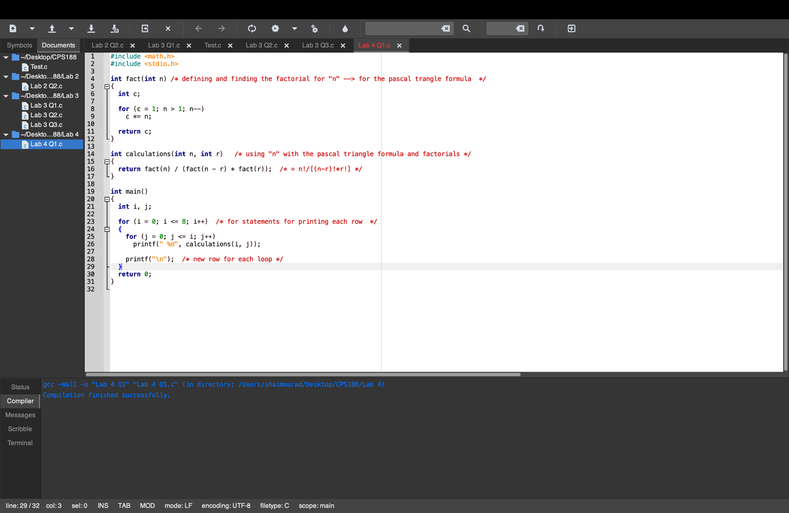

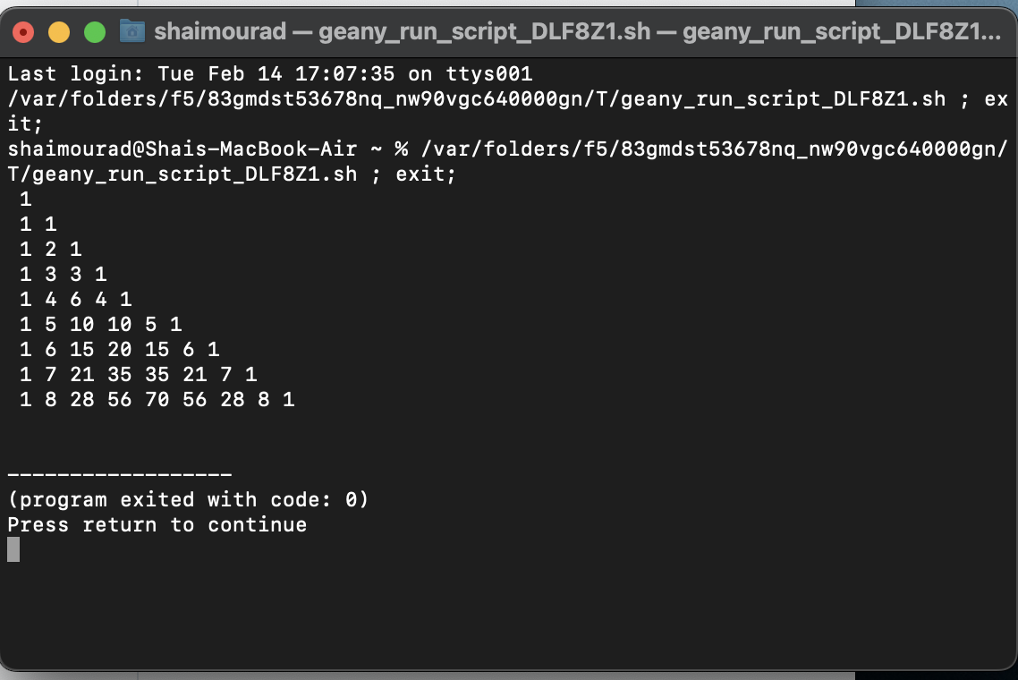

QUESTION #2:

- Ask the user how many employees there are
- Ask the user for each employee,
  - The employee number
  - Wage
  - How many shifts completed
  - How many hours per shift
- Calculate the number of total hours by multiplying shifts and hours per shift together
- Calculate the gross pay, which is the total amount of hours multiplied by the wage
- If the employee works for a certain amount of time, they get a premium
  - For < 15 hours, they have no premium
  - For > 15 but < 25 hours, they get a 5% increase in wage
  - For > 25 hours, they get a 10% increase in wage
- Create a list in columns with the headings:
  - Employee no.
  - Total hours
  - Gross pay
Fill in the list correspondingly.

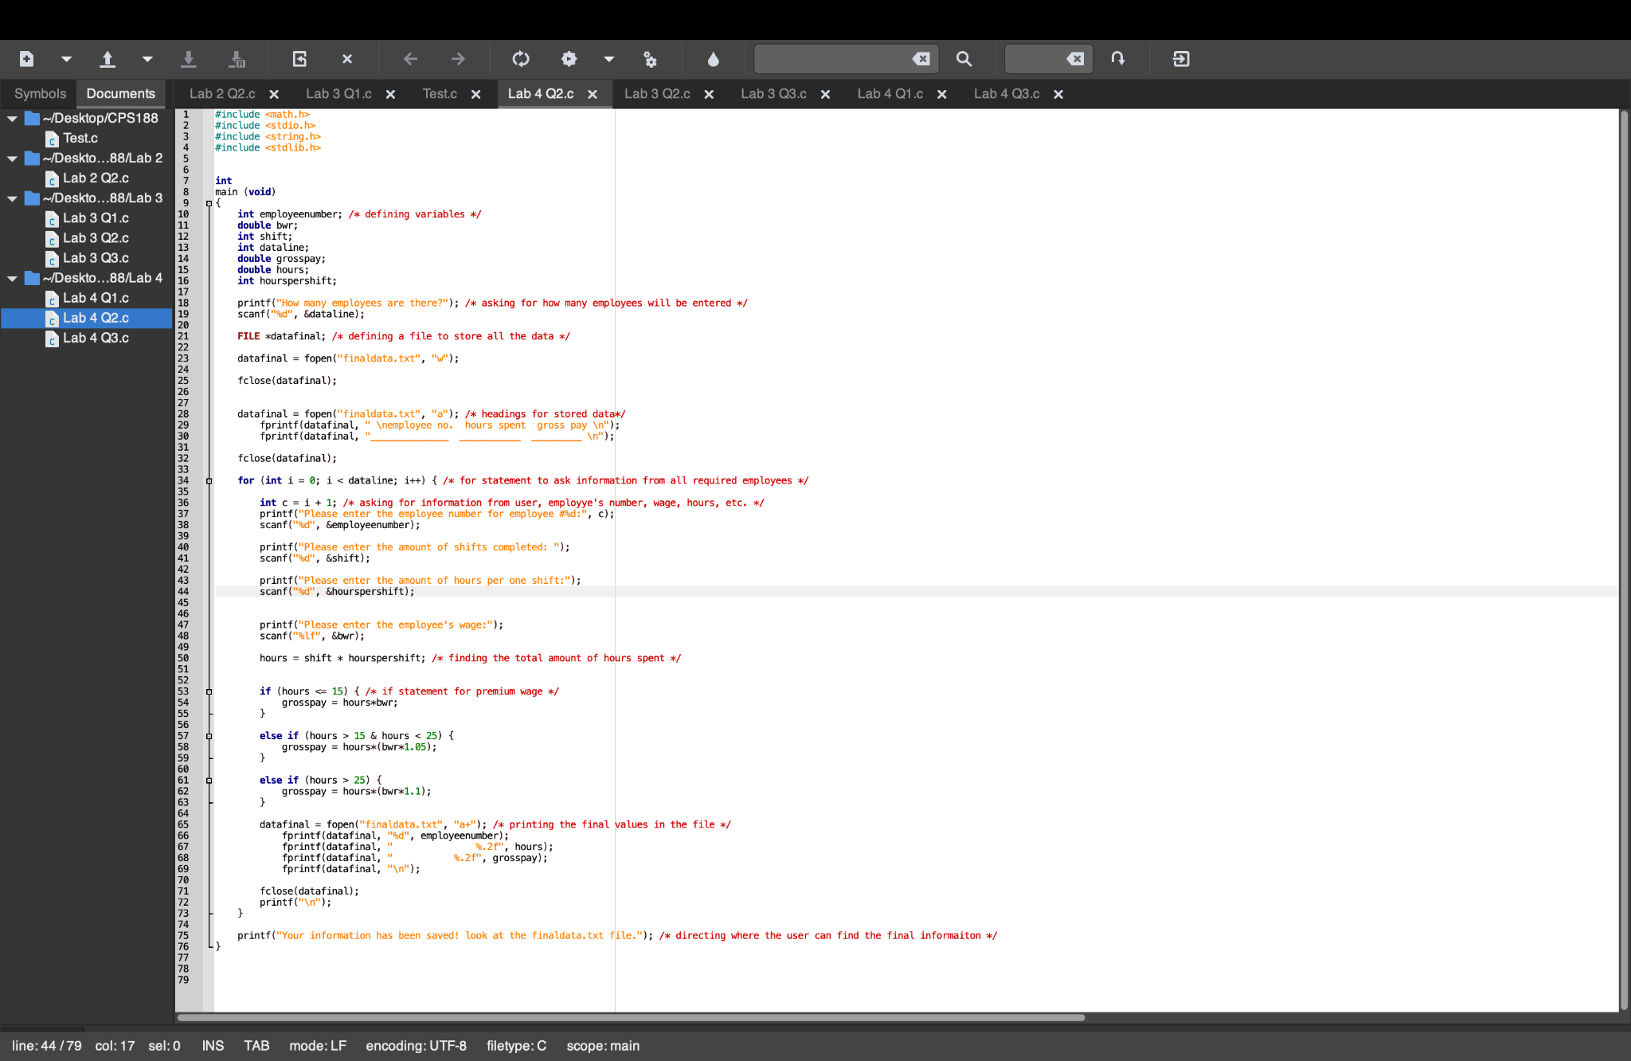
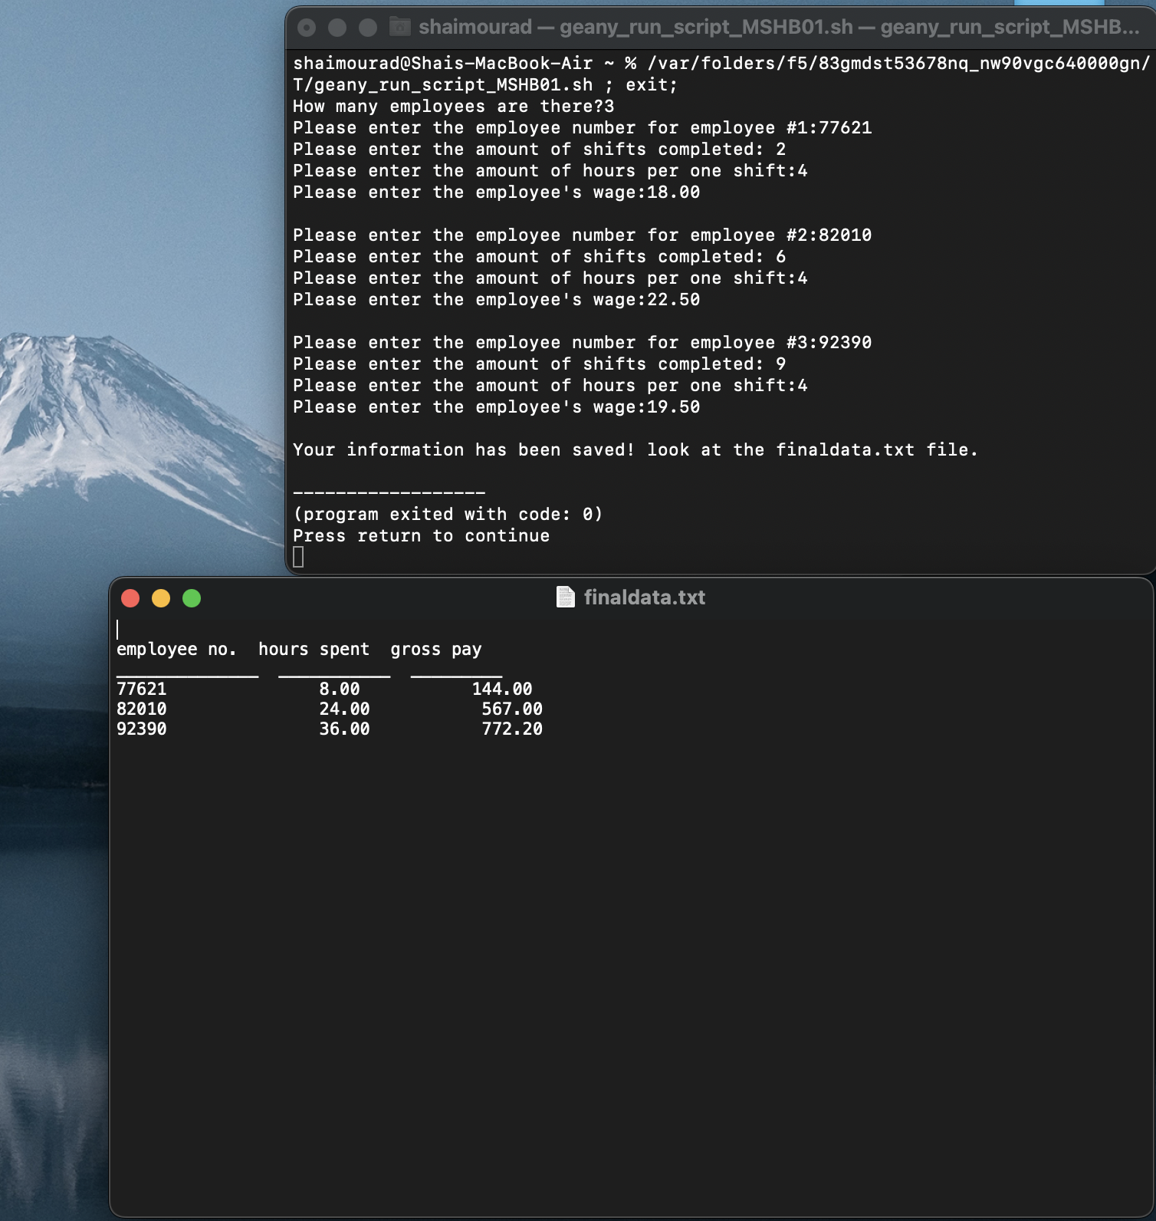

QUESTION #3 (note that a. and b. Are combined into the output table):
